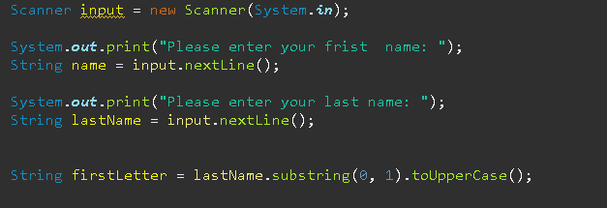

My code starts by having a scanner. The program asks the user to input their first and last name. The Called input allows the user to import their name; the usual extent is used for a number that doesn’t have decimals but because the program asks for a letter. We need a string I used Nextline for the user to import their name then the program takes the full name. Lets say you input the name Mohamed Mahmoud and takes the group assignment asked for their last name be classified to the individual groups so the variable Called first letter uses the scanner class only takes the first letter for the word and because the next part of the code uses uppercase letter I needed to add a scanner class to make the FristClass variable contain only an uppercase letter.

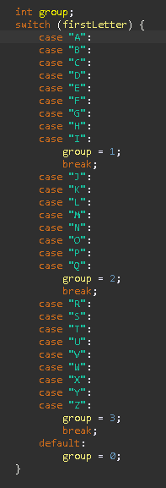

My code uses a switch statement to make it easier for me to classify the groups; the switch only happens if the user import fits the requirements for the variables FirstLetter . The switch uses the FirstLetter to choose which case it fits to get the groups Ex. A for group1 . Then I made a default if the user import somehow fits the requirements for FirstLetter but not for the case it classed as group0.

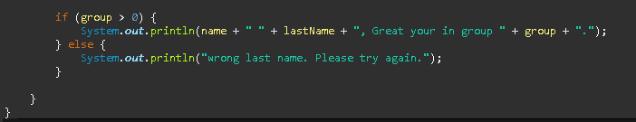This code checks if the variable Group is greater than 0, indicating that the last name falls into one of the defined groups. If true, it prints a message confirming the user's name and their group assignment; otherwise, it prompts the user to try again due to an invalid last name.

After the switch the results of groups that case the user (fristLetter) the switch result splits into If and else statement if the group selected greater than 0 means that user import as valid and gives the user name and last name and same group. Else the it’s wrong and the only group that goes into the else statement is the group0.

This reflection log was for Group Assignment

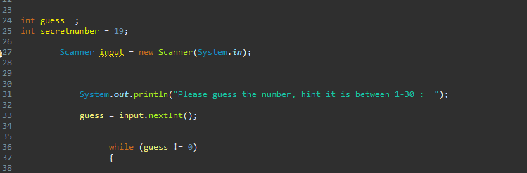

Here I have a input statement for the user to input the value and try to guess the number here In chose the number 19

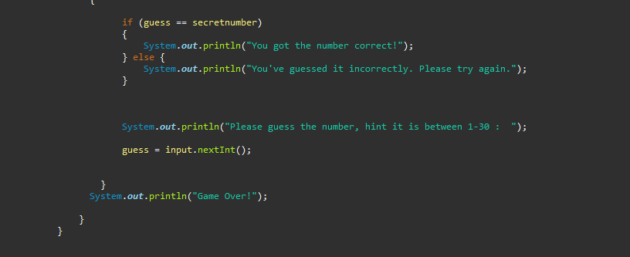  
This reflection log was for GuessingGamePart2

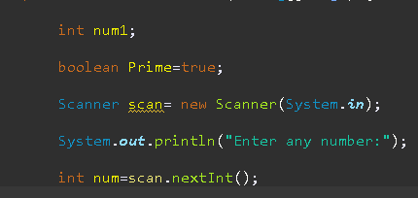

The first lines of code is usually for the input section of the ipo the code asks for the user to enter a number through using a scanner. Then the code uses a boolean variable called prime equals to true to let the code continue if the user followed the requirement the prime + true is used later in the process process.

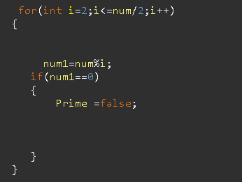

The second of the code is using the loop (for) in the beginning to have the number in the form (num) the variable of the user's input is processed by having requirements such as being divisible by 2. Then if the variable (i) is less than or equal to num divided by zero is allowed to be in the for loop. In the for loop there's a If statement that sets another path by having the (num1) equal to 0 lets the loop have a boolean variable to display the num to be not a prime number.

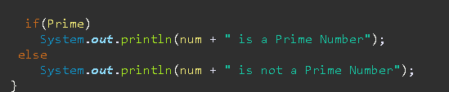

This is just the output having a number that has been processed into the for loop if the for loop is prime number then it skipped past the if statement if the number isn’t a prime number then it goes through if statement and be output through the else statement as the (prime = false).

This reflection log was for Prime Number